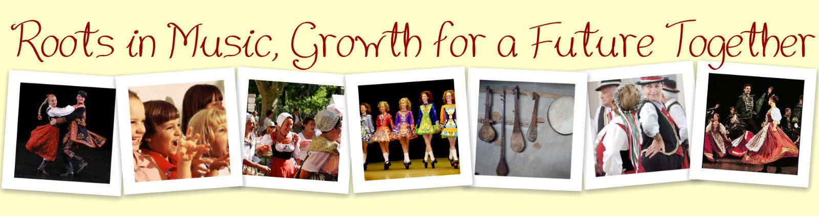
4th Project Meeting in Zsombó, Hungary
18-23 March 2012

~ Working paper ~
1. Our website: http://rootsinmusic.jimdo.com/ main project product
- We collect all our materials here.
- Important source of information for teachers, students, other people.
- What can you find here?
  - description of the project
  - work sharing scheme
  - useful information about the participating countries, settlements, schools
  - project diary: description of all the meetings (to help you when writing the final report)
  - dissemination work in the countries should also appear on the website
  - overall evaluation table – must be filled in
  - description of the activities: so far we have completed (more or less) 8 activites
  - language learning section: Pals’ Corner (you can also start a new topic for children, they like it ), monitored chatboard: Shoutbox,
  - multilingual blogs: Makó, Zsombó, Zambrów, Stigliano it helps disseminatation, informs local people in their language and help you to remember things (Final Report)
  - Fun Corner: for children or for you to use in class
  - Teacher’s Corner: ComDiGro (please use it , or at least read it sometimes ), we are trying to learn from one another, so useful web 2.0 tools, tutorials and IWB resources are available here we should improve our computer skills, too
  - optional parts: seasonal photo gallery, guest book, seoasonal greetings, diary etc.
- eTwinning project TwinSpace (mainly coordinated by Barbara and Edit)

2. Activity Checklist
Activity 1: Getting Started
- Create a video message or slideshow to introduce the Comenius group of your school
- Create a glog and/or a collage/video to introduce the participating classes/your country/your town or village/your school
- Send a simple recipe
- Do a videoconference with your partner school
- Evaluation
Activity 2: A National Composer
- Create a video or a presentation about one of your national composers. You should include: a photo of the composer, place and date of birth, some interesting facts about his/her life, some famous works.
- Make a short and simple online quiz to test the other's knowledge about your national composer.
- Do a videoconference (or a chat lesson) with your forthcoming partner school about family and friends.
- Evaluation

Activity 3: Picture Your Song
- Create pictures to illustrate your traditional song.
- Write your own story to each country's story pictures.
- Do a videoconference (or a chat lesson) with your forthcoming partner school about favourites (subjects, activities etc).

Activity 4: Traditional Video Clips
- Create a motion picture (animated movie, video clip etc.) to illustrate your traditional song.
- Add your opinion to the Comments section.
- Do a videoconference (or a chat lesson) with your forthcoming partner school about eating habits, food and drink.

Activity 5: Let’s dance!
Create a movement or dance: First, dress in your national costume and film your folk dance performance. Then, choose one of the partner country's songs, film your freestyle dance performance and send your videoclips.
- Folk dance performance
- Freestyle dance to a chosen song
- Let's learn about national folk costumes
- Add your opinion to the Comments section.
- Do a videoconference (or a chat lesson) with your forthcoming partner school.

Activity 6: Our Story – Your Song
- Find out a story based on the comics/pictures to every illustration and write it in the Comment part below the illustration.
- Write a comment or evaluation to every story written to your song
- Is it close to the original story?
- Is it better than the original one?
- Do you like it?
- Which part is correct?
- You can choose the best one.
- Do a videoconference (or a chat lesson) with your forthcoming partner school about e.g. each other's comments.
Activity 7: The Science of Music
1. Numeracy
- Do these 2 activities on the Interactive Whiteboard.
- Take about 5 photos while doing these activities and send them to the website.
- Sing and/or clap your Comenius song. Use a metronome to help you. Record it and send the video to the website.
2. Science
- Create a video and try to use English while commenting it.
  - Singing Rod
  - Screaming Balloons
  - Screaming Cup
  - Singing Glasses
  - Singing Pipes
  - Musical Straws
  - Water Whistle
  - Buzzing Noise Maker
  - Whirly Tube
- Do a videoconference (or a chat lesson) with your forthcoming partner school. (VC Lesson 7)
Activity 8: The Language of Music
- Listen and watch the Basic Vocabulary tutorial.
- Choose 10 words from your folk song and create a Pictionary to teach them. Include
  - the word and its English equivalent
  - an image
  - the pronunciation
- Solve the final quiz and create a funny video about your multilingual progress.
- Write your opinion in the PenPal Corner about learning languages.
- Do a videoconference (or a chat lesson) with your forthcoming partner.

