Questions to help you:

- What’s your first name?
- What’s your family name (surname)?
- How can I call you? What’s your nickname?
- How old are you?
- Where do you go to school?
- Where do you live?
- What is your hobby?
- What is your favourite subject?
- What is your favourite animal?
- What is your favourite colour?

1. First name: ___________________
2. Family name: _________________
3. Nickname: ___________________
4. Age: ________
5. School: ________________________________________
6. Village/Town: ________________________
7. Hobby: ______________________________
8. Favourite subject: ____________________
9. Favourite animal: _____________________
10. Favourite colour: _____________________

paste photo here
Some vocabulary:

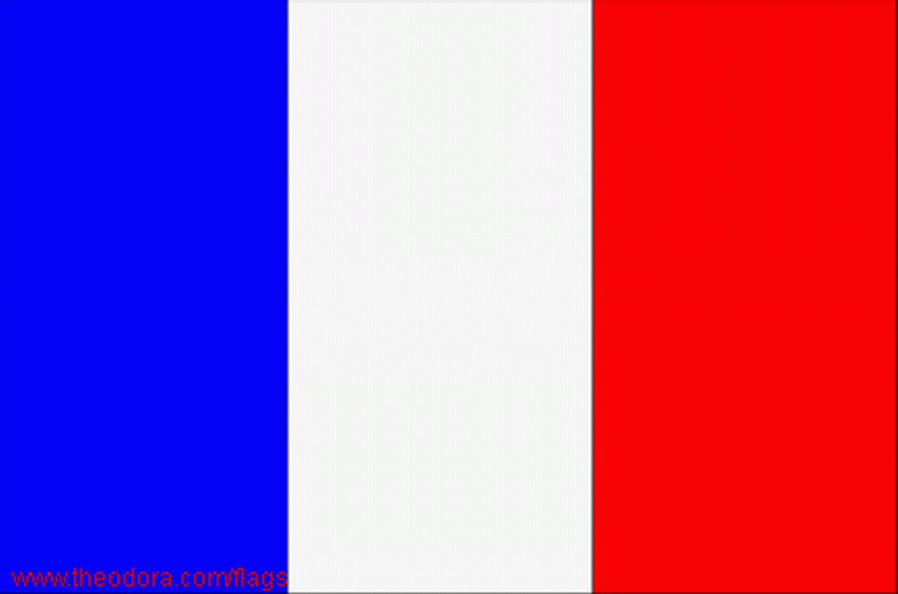  in French – en français – franciául: | 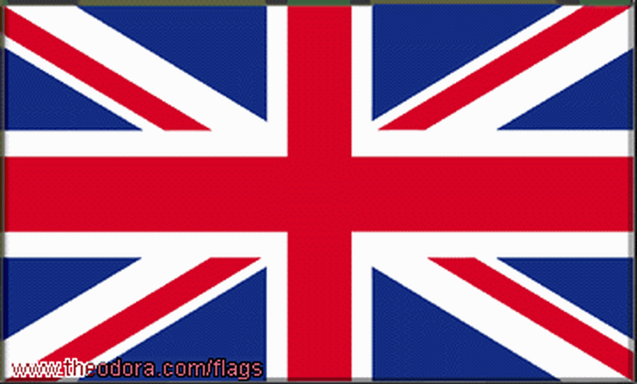  in English – en anglais – angolul: | 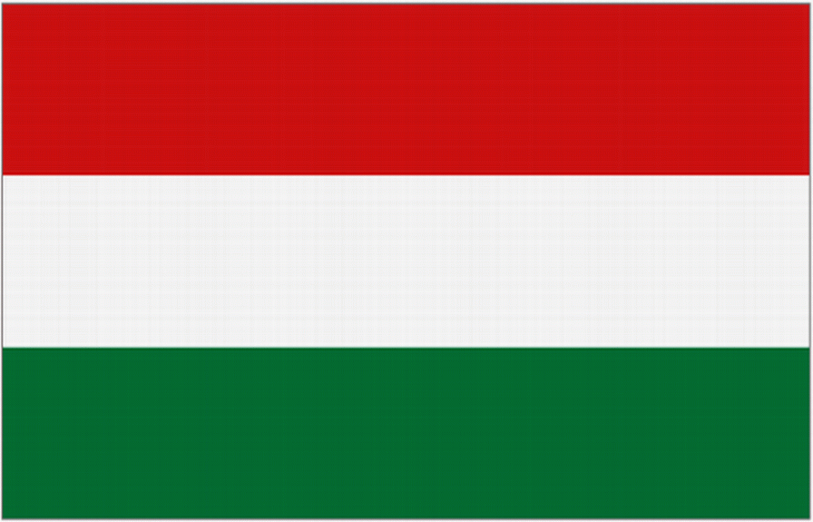  in Hungarian – en hongrois – magyarul:
Salut! | Hi. | Szia!
Bonjour! | Good morning! | Jó reggelt!

